Métier description report
Josefine Egekvist, DTU Aqua
02 maj, 2019

Region: North Sea and Eastern Arctic

Métier: OTB_DEF_>=120_0_0 , years: 2015,2016,2017
Data source: RDB CE and CL data
Number of trips by flag countries: BEL, NLD, DEU, ENG, POL, PRT, DNK, SCT, SWE, ESP, IRL, NIR, FRA, LVA, EST
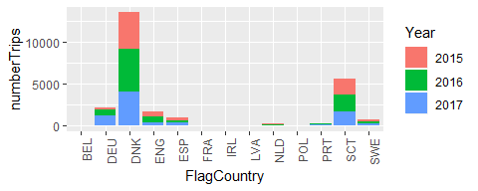
Top 10 species landed by métier. The rest are summarised in “Other species”. Average yearly landings during the period 2015,2016,2017 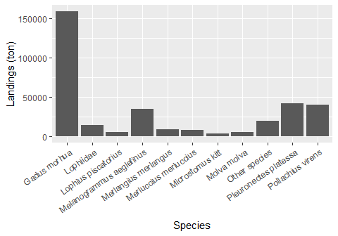

Number of trips by vessel length group:
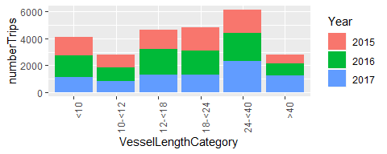
Seasonal pattern of fishing activity: number of trips by quarter
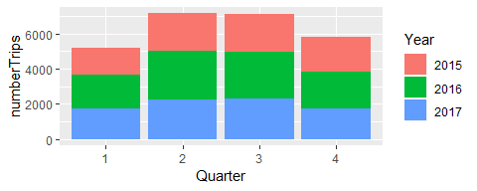
Days at Sea by ICES rectangle, yearly average 2015-2017 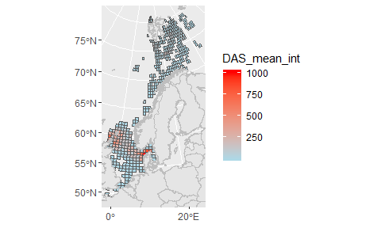
Comments:

